<https://onejira.verizon.com/browse/NTSCE-14733>  
select * from fuze_copy.site_info@fuze_uat_read;

Env-UAT  
TC_01 Verify users can change site status for SARF sites.  
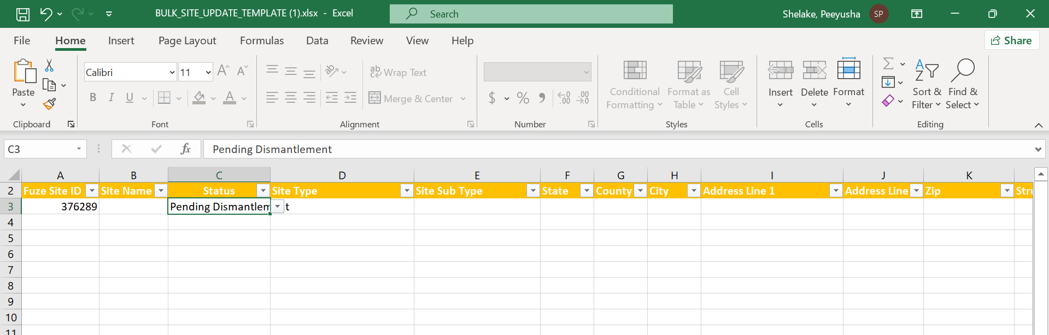  
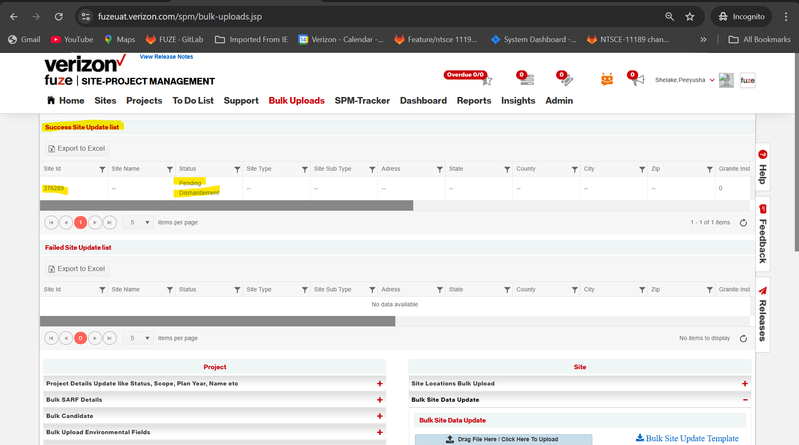  
TC_02 Verify user cannot change site status for Non-SARF Sites  
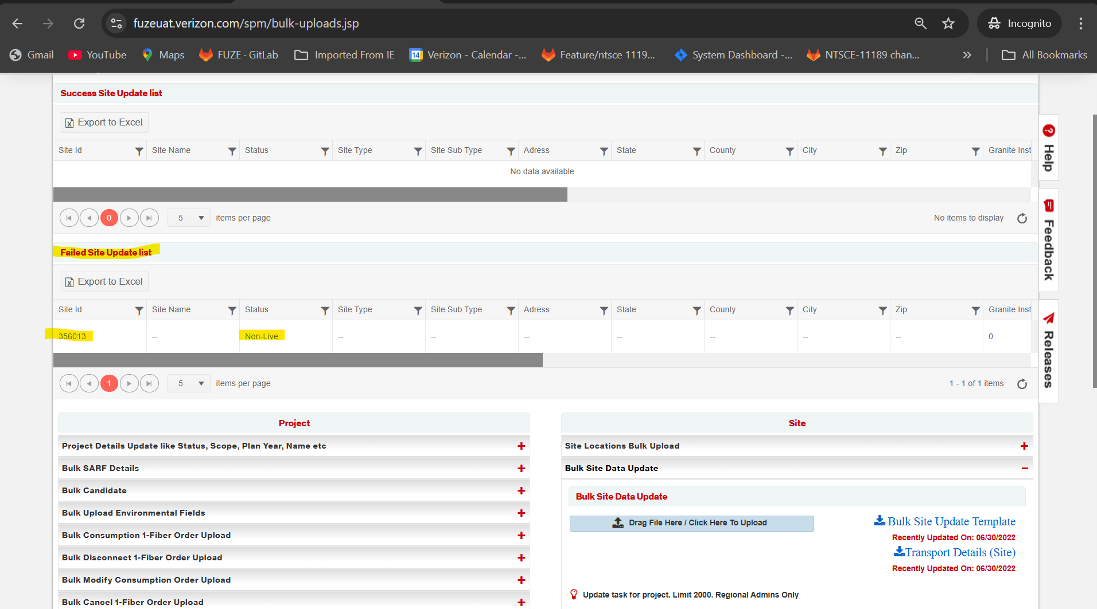  
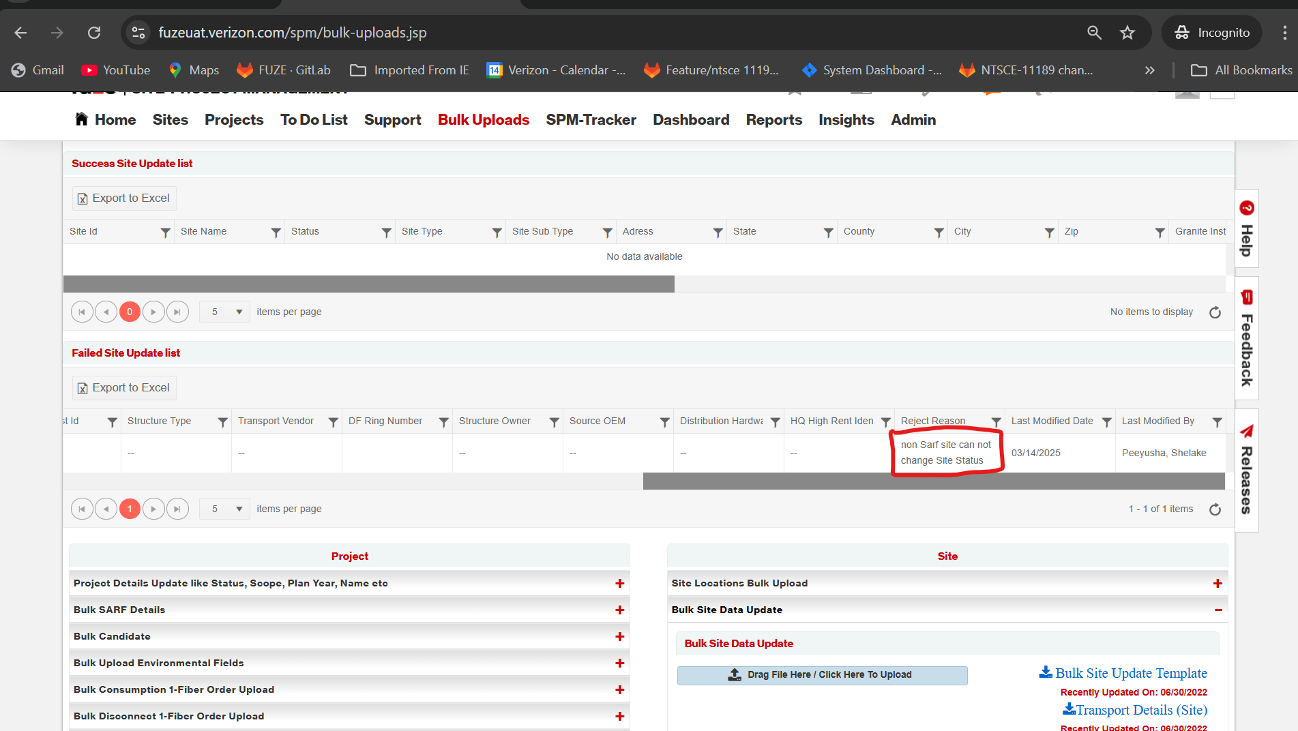  
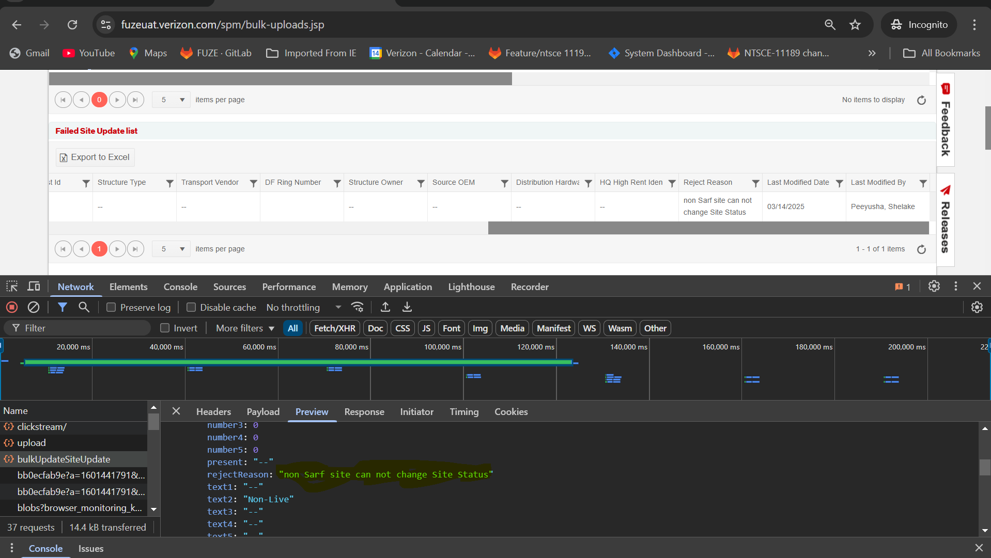  
TC_03 Verify users without GUI_SUPPORT role cannot change site status.  
